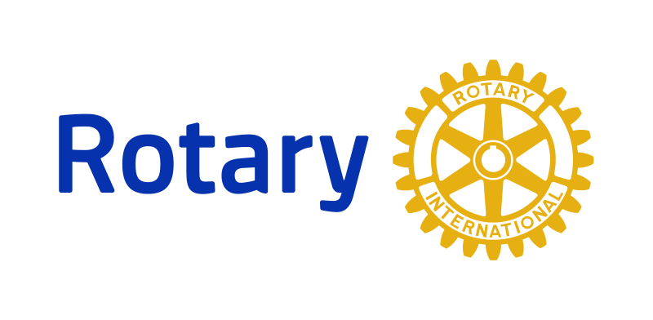**Rotary Trivia for**

**New Members**

Welcome your new members to Rotary by playing a friendly game of trivia during a new member orientation session! Better yet, test your entire membership’s Rotary knowledge by playing trivia during a regular meeting. Here are a few trivia questions to get you started!

**1. When and where was the first Rotary Club founded?**

Answer: The first Rotary Club was founded on February 23, 1905, in Chicago, Illinois, USA.

**2. What is the official motto of Rotary?**

Answer: The official motto of Rotary is "Service Above Self."

**3. What are the six areas of focus for Rotary's service projects?**

Answer: The six areas of focus are: promoting peace, fighting disease, providing clean water and sanitation, supporting education, saving mothers and children, and growing local economies.

**4. What is the Rotary Foundation, and what does it do?**

Answer: The Rotary Foundation is Rotary's charitable arm, which supports local and international service projects and scholarships.

**5. What is the significance of the Rotary wheel?**

Answer: The Rotary wheel is a symbol of Rotary, representing the organization's commitment to service and progress.

**6. What is the Four-Way Test, and why is it important to Rotary?**

Answer: The Four-Way Test is a set of ethical guidelines for Rotary members to follow, which asks the questions: Is it the truth? Is it fair to all concerned? Will it build goodwill and better friendships? Will it be beneficial to all concerned? It is important to Rotary because it helps guide members in making ethical decisions and promoting goodwill.

**7. What is the Paul Harris Fellowship, and how do members become a Paul Harris Fellow?**

Answer: The Paul Harris Fellowship is named after Rotary's founder and is awarded to members who have made significant contributions to Rotary's service projects and mission. Members become a Paul Harris Fellow by donating $1,000 or more to the Rotary Foundation.

**8. What is the Rotary Youth Exchange program?**

Answer: The Rotary Youth Exchange program is a cultural exchange program for high school students, which promotes international understanding and goodwill.

**9. What is the Rotary International Convention, and where is it held?**

Answer: The Rotary International Convention is an annual event that brings together Rotary members from around the world to share ideas, learn from each other, and celebrate Rotary's accomplishments. It is held in a different location each year.

**10. What is the Interact Club, and who can join?**

Answer: The Interact Club is a Rotary-sponsored service club for young people ages 12-18. It provides an opportunity for young people to get involved in service projects and develop leadership skills.